Language is Confrontation
—Reflections sparked by Yan Lei’s solo exhibition Bilder, die(nie) verschwinden
Yan Lei: Bilder, die(nie) verschwinden
Tang Contemporary Art Centre, Beijing
September 6 - October 20, 2014
In 1956, instructed by Premier Zhou Enlai, the Peking Opera performance artist Cheng Yanqiu played the main character in Tears from Barren Mountain, a Peking opera film written and directed by the Party dramatist Wu Zuguang. Apparently, this founder of the “Cheng school”, then already corpulent, devotedly presented more than two hundred “water sleeves” movements within the drama. In 1957, during the Anti-Rightist campaign, Wu Zuguang was purged; meanwhile, Cheng Yanqiu was sitting on the stage silently with brows furiously knit.
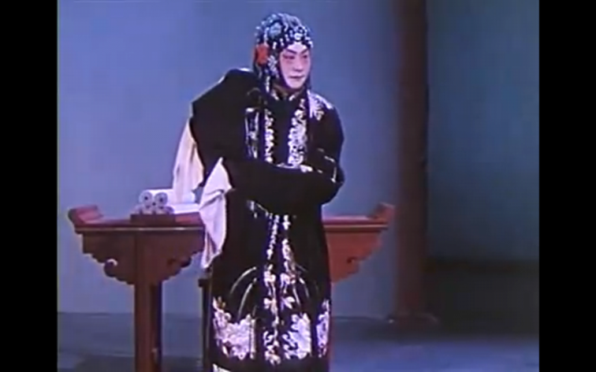
Master Cheng Yanqiu in the Peking Opera film Tears from Barren Mountain (1956)
It was when I was standing at Yan Lei’s exhibition “Bilder, die(nie) verschwinden”, held in September 2014 at Tang Contemporary that this episode came to me—which sounds completely unrelated. Since Peking Opera was close to the masses and was particularly well liked by certain leaders, it was called a “national quintessence” (guosui) and could not help but suffer the painful experience of being reformed. With his reputation as a master, Cheng strived to reform Peking Opera and strived to make sure it matched the times and maintained unity with the direction of the Party. He fused his distinctive “Cheng-style” tone and water-sleeve movements into the Tears from Barren Mountain, the film he first directed in 1930 reflecting the sufferings of the laboring masses. However, this Cheng-style idiom of Peking opera was obviously a product produced under the intimidation of political ideology, a self-purified rhythm and formal expressive form without historical sensibility. There, the artistic idiom must march to the metronome of Socialist Modernization, outputting the correct values of the People, and serving the requirements completely and utterly.
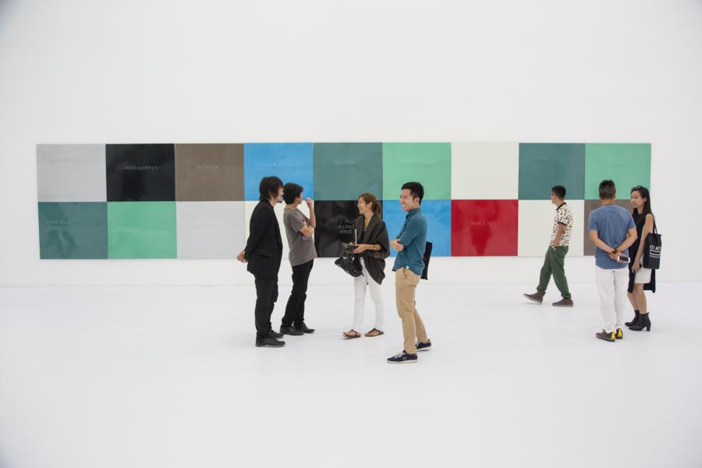
Yan Lei, Bilder, die(nie) verschwinden, Tang Contemporary Art Centre, Beijing
Following from the train of thought from his “Limited Art Project” presented at the 2012 Kassel dOCUMENTA, Yan Lei’s solo exhibition is mainly composed of several groups of pure aluminum plates simply arranged. On these plates, English words are inscribed, which describe the contents of the original images before they were spray-painted. The content of these words are “infinite”—“Girls from Ancient Italy”, “Tempura”, “A Page from Mao”…—numerous materials from the fields of the everyday and politics to art history. At the exhibition entrance is a video clip revealing the process in producing the works. The artist himself planned the meticulous process from the selection of the underlying photographs all the way to the production of the images, and then extricates himself and leaves, handing over the work entirely to workers to paint. At the Kassel dOCUMENTA, every day, one of the many images hung up and fully covering the wall was taken to the factory to be spray-painted in a monotone hue, so the works at Tang Contemporary naturally derive from a similar strategy.
In the video, Yan Lei sits on the side of the road leaning on a painting. What is he thinking? Is he feeling helpless in the face of the imagined images propagated by reality? Is he feeling doubtful about his own position in the world? Is it about what art is for? In one conversation, this taciturn artist once said: “Every artist will envy Andy Warhol. His works remind me of how I should express my own desires”¹. Desire, in his instinctive pathway where he does not shy from stating doubts about art, can reach images without obstructions and with control abandoned. Not believing that art serves as the bridge between the subject and the world, from then on, Yan Lei conducted an image practice of many years. This artist, who once faked letters inviting artists to the Kassel dOCUMENTA, both wants to resist the hegemony of global art and yet also observes the lack of choices in his own existence. He constantly travels to the West, being in touch with an even more systematized and elitist art system, while at the same time, he feels uncertain about what to do in the face of the predicament subtly caused by the political climate within the domestic environment. He seems to waver between systemic critique and internal exile.
Yan Lei’s split is not an individual case; to a certain degree, it was predictable. He believes that art depends on attitude, so he uses a roundabout way to extricate the artist from the process of producing the work, delivering a note to us from afar: since the world is like this, we will let it be like this. He is of that generation of Chinese artists who from the start of his career had to face the proliferation of systems, the market boom, and the flood of media; in his own experiences are etched the conflicts of those within and those without. The difference between the official system and the wilderness [i.e. outside the system] domestically seems easy enough a choice; the arrival of the West, however, can hardly be said to be a simple blessing. In the 1980s, the experiences of fellow travelers and pioneers, to a certain extent, are in Yan Lei reduced to an understanding and reflection of “accepting” and “being accepted”: whether official or unofficial, Western or domestic, society or art, within art or without. They toss and turn within these coordinates, placing all kinds of references and experiences which rush into human life within the calculations of a creative consciousness in search of solidity. This beginning is the origin of his own split in his work; the life experiences faced by the artist himself in this “over-flooded” world ended up being the surface image of his creation.
In the mid-90s, the linguistic critique which arose with Qiu Zhijie as a representative figure influenced the works of many artists. In this dispute, the visual linguistics with Cynical Realism and Political Pop as the criteria was placed squarely in the court of judgment. Emerging artists were not satisfied with the illustrative nature of cultural symbolism, and also cried out to break down this middle-class mode of thought. If it is said that such a linguistic critique broke down a certain formalized art historical narrative with its courage, prescience and clear political demands, by today in 2014, questions about language, especially that of visual languages, do not yet appear to have a greater sense of the contemporary. Its relationship with the market and the art system have become far too entangled, which led to either treating visual language as the final point—not caring how to get there, at least ensuring the work’s completeness formally as well as its theoretically ambiguous relationship—or else relying on the “talent” of the artist, abruptly cutting off the nomadic experience from the foreign to the domestic, the individual to the collective, forcibly extracting a plausible linguistic logic. The previous shadows projected by Minimalism and Warhol, however, still exist albeit in diluted form in emerging artists’ various techniques like substituting labor, making things to order, institutional critique, environmentalism, living away from home, participation— fundamentally, whether it is the study of the image in simplifying things or its reverse, whether it uses the embellishments of political stance of “This is not my age” or the “observer”, it does not escape an impotent and selective loss of memory.
This schizophrenic split in the linguistic perspective is presented above the production of de-subjectification and the intense molding of a solid desire for an (anti) image logic. It must respect the global trends in the popularization of art while declaring at the same time that any art must have its self-restraining sphere and the power to select. Yan Lei’s character is not secretive; he could bring the band “Brain Failure” to perform at the Istanbul Biennale as his own work, and he could also convince the Shenzhen city government to grant him an empty piece of land, letting it lay unused for two years. Behind these works, constantly hitting their targets, there is however the specter of negotiating the rules.² Hence in Yan Lei’s practice, creation always has a sense of an empiricist guerrilla war. A bit like the dialogue on the conference table, all confrontations aim at the ultimate results.
Standing in front of any of Yan Lei’s monochrome paintings, the cold, reflective aluminum boards unevenly reflects the spectator’s visage. The carefully selected metallic texture creates this introspective relationship; in front of viewers who might mock or ridicule or else wantonly speculate, the artist seems to situate himself on the outside. “I believe the highest quality of art is that the object cannot represent; it exists outside language.”³ Language is described by the artist as a secondary expressive method. What is outside language? This attitude of self-exile is not more advanced than that of the Cynical Realism or Political Pop of the 90s. The imagination of the “highest quality” can hardly even compare with that blurry and progressive impulse in the Enlightenment utopia of the 1980s.
This is a surface phenomenon in the level of visual language of contemporary Chinese art of recent years—and even a metaphor for an age. The question of visual language has become an unreliable hermeneutic cycle, collapsing into an infinite intellectualizing displacement between “image and the world”. This disparate result is the vacuum of thought. We do not understand on what basis do artists speak to whom, or whether artistic creation still has the power of generating theories; we suspect even more that within our country where official ideology is increasingly systematized and valued, strengthened to the point where it can be everything, what position art is situated. This resembles Cheng Yanqiu’s awkwardness in the 1950s to the extreme, only that Cheng chose to reform himself, entrusting his artistic language to the country’s historicist hallucinations and responsibilities, while today, many “unofficial” (lit. “in the wilderness”) artists would rather fragment and exile themselves. They reckon how could formal language so directly clash with reality?
But one could only wish that when artists work seriously, there can still appear certain moments when they are harsh on themselves. After all, there still are people on the street crying about things directly related to them, and there are thinkers who excavate hints in the recesses of consciousness. The independence of artistic language lies not in forging a formal labyrinth from whatever motives, nor is it an unattainable vision of the future. It should be able to exist under the guidance of a creative consciousness that directly confronts, within a dynamic relationship of the world. Can art still confront truthfully and honestly, and not care for the consequences? Can thought and power still clash one more round? Before we exonerate our weak and feeble art with the overall artistic predicament, we still need to do, to practice.

Footnotes:
1. Carol Yinghua Lu, 'Anything that can't become art?: A Conversation with Yan Lei', Art and Investment, No. 7, 2008.
2. Hou Hanru, 'Negotiating the Non-Negotiable: On the Work of Yan Lei', Art and Investment, No. 6, 2008.
3. Wang Jing, 'Limited Art Project: Reexamination of Image Violence', Master ‧ Oriental Art, No. 13, 2012.

